**Background:**

* 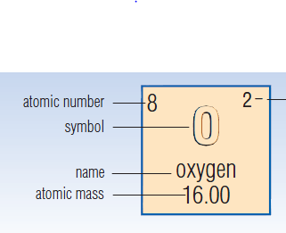All elements known to Science and Chemistry are listed on the periodic table.
* Each element has a box in the table which lists its basic information according to the key below.

**The First 20 Elements:**

|  |  |  |  |  |  |  |  |  |  |
| --- | --- | --- | --- | --- | --- | --- | --- | --- | --- |
|  | **Day 1** | | | | **Day 2** | | | | **Day 3** |
|  | **Element Name** | **Element Symbol** | **Atomic Number** | **Atomic Mass** | **# of**  **Protons** | **# of**  **Electrons** | **# of Neutrons** | **Standard Notation** | **Lewis Dot**  **Notation** |
| 1 |  |  |  |  |  |  |  |  |  |
| 2 |  |  |  |  |  |  |  |  |  |
| 3 |  |  |  |  |  |  |  |  |  |
| 4 |  |  |  |  |  |  |  |  |  |
| 5 |  |  |  |  |  |  |  |  |  |
| 6 |  |  |  |  |  |  |  |  |  |
| 7 |  |  |  |  |  |  |  |  |  |
| 8 |  |  |  |  |  |  |  |  |  |
| 9 |  |  |  |  |  |  |  |  |  |
| 10 |  |  |  |  |  |  |  |  |  |
| 11 |  |  |  |  |  |  |  |  |  |
| 12 |  |  |  |  |  |  |  |  |  |
| 13 |  |  |  |  |  |  |  |  |  |
| 14 |  |  |  |  |  |  |  |  |  |
| 15 |  |  |  |  |  |  |  |  |  |
| 16 |  |  |  |  |  |  |  |  |  |
| 17 |  |  |  |  |  |  |  |  |  |
| 18 |  |  |  |  |  |  |  |  |  |
| 19 |  |  |  |  |  |  |  |  |  |
| 20 |  |  |  |  |  |  |  |  |  |

**Questions:**

Day 1

1. What do you notice about how the Periodic Table is organized by the Atomic Number of the elements?
2. What do you notice about the Atomic Mass of the elements?

Day 2

1. What do you notice about the number of protons and the number of electrons for each element?
2. Are the number of neutrons related to the number of protons or electrons?

Day 3

1. What pattern do you see in the Lewis Dot diagrams showing the outer valence electrons for each element in the same column?
2. What pattern do you see in the Lewis Dot diagrams for each element in the same row?